**Documentation package for forget password feature (story 133).**

**Use cases**

|  |  |
| --- | --- |
| ***Use Case Name* (SPW5_106)** | **Forgot password** |
| ***Participating Actor*** | Student |
| ***Flow of Events*** | 1. Student clicks on the “Forgot Password” button. 2. The system displays dialog prompt containing a form. 3. Student enters email address associated with his/her account, and clicks on “Send” button. 4. The system sends a message to given email address with instructions for changing password. |
| ***Alternative Flows*** | 1. Student does not enter correct email, which causes the system to display a message informing about incorrect email address. |
| ***Entry Conditions*** | * Student has navigated to login page. * Student has a manually created account. |
| ***Exit Conditions*** | * Student successfully requested change of profile password. |

|  |  |
| --- | --- |
| ***Use Case Name* (SPW5_107)** | **Changing password with forgot password feature** |
| ***Participating Actor*** | Student |
| ***Flow of Events*** | 1. Student clicks on the link provided in the message from the system. 2. The system navigates to page allowing the Student to change password. 3. Student inserts new password in the top form, then inserts the same password in the bottom form; finally clicks on “Save Changes”. 4. The system navigates to login page, and displays a message informing about successful change of password. |
| ***Alternative Flows*** | 1. Student does not enter valid password, which causes the system to display a message prompting for use of valid characters and/or valid length. |
| ***Entry Conditions*** | * Student successfully used forgot password feature to request password change. * Student has received the message from the system on his/her email account. |
| ***Exit Conditions*** | * Student successfully changed profile password. |

**Sequence diagrams**

**SPW5_106 (forgot password)**

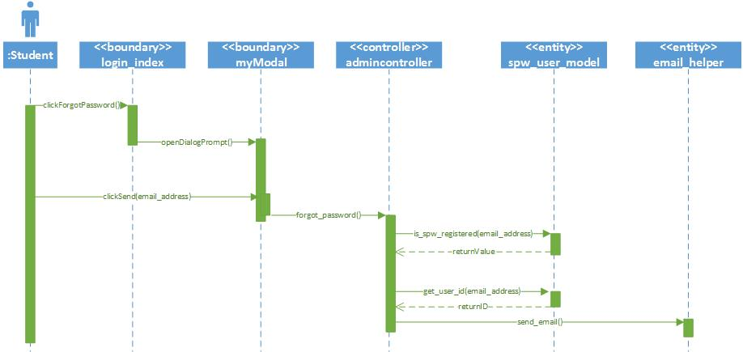

**SPW5_107 (changing password with forgot password feature)**

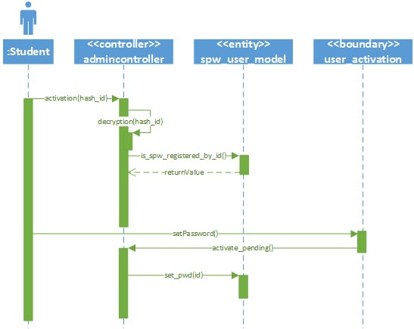

**Class diagram**

Login Subsystem

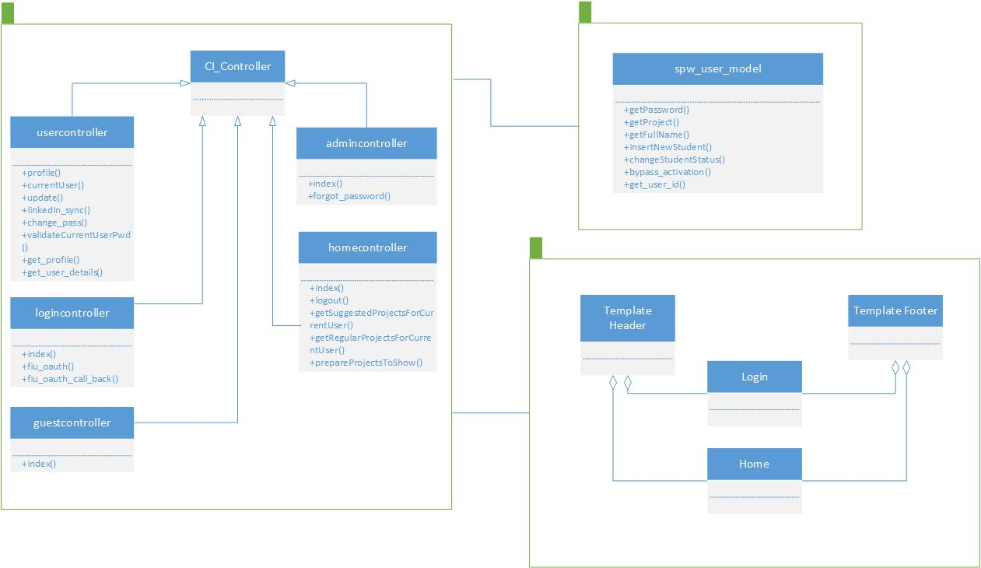

**Segement for user manual**

**How to change password using forgot password feature.**

1. On the login page click on “Forgot Password?” button.  
   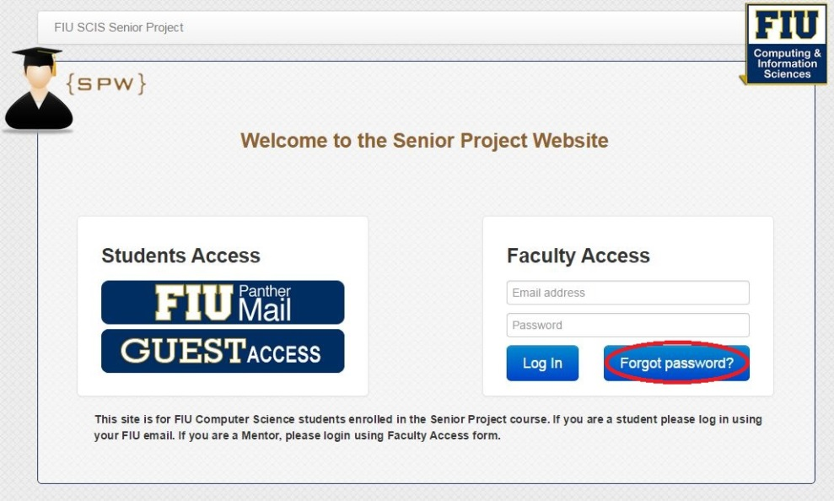
2. Once dialog prompt appears, enter email address associated with your spws account, then click on “Send”.  
   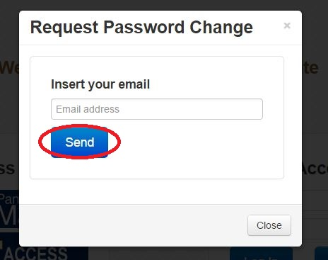
3. Message with instructions on how to change your password will be sent to your email address.

**<there will be a second part to this manual once I have my task branch merged with develop>**